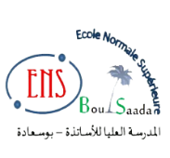


Title of the manuscript

Author Oneª, Author Two^{b} and Other^{c}

ª University or Company, Department, City, Country (11 Font size)
^{b} University or Company, Department, City, Country
^{c} University or Company, Department, City, Country

author@mail.dz

Extended abstracts accompany all articles submitted for the 1st NCC-AS. They serve as a concise yet comprehensive summary of the research and are intended to provide readers with a clear understanding of the study’s objectives, methodology, key findings, and conclusions. Extended abstracts are essential for indexing and literature searches, ensuring that the research is accessible and valuable to the broader scientific community. Authors should ensure clarity, coherence, and adherence to the provided template to facilitate effective communication of their work.

Title: Times New Roman, 14 pt, Bold, Centered
Authors' Names and Affiliations: Times New Roman, 11 pt, Centered
Abstract Text: Times New Roman, 12 pt, Justified
Keywords: Italic, Times New Roman, 12 pt
Length: Maximum 300 words
Language: English, Arabic or Fernch
Keywords: First Keyword, Second Keyword, Third Keyword, Forth Keyword.

